Aplicaciones Ofimáticas (Office Applications)  
Unit 03. Highlighting and annotation guide with Okular

short line

Authors: Sergi García Barea, Gloria Muñoz González

Updated October 2022

Licencia

**Reconocimiento - No comercial - CompartirIgual** (BY-NC-SA): No se permite un uso comercial de la obra original ni de las posibles obras derivadas, la distribución de las cuales se ha de hacer con una licencia igual a la que regula la obra original.

**Índice de contenido**

**1. Okular. Highlighting and annotation tool.** **3**

**2. Annotating with Okular** **3**

**3. Tips for annotating and highlighting** **4**

**4. Example of highlighting, underlining and annotating** **5**

# Okular. Highlighting and annotation tool.

Okular is a universal document viewer. It's cross-platform, fast, and packed with a lot of features.

Among other things, it allows you to read documents in PDF format, comics (“.cbr” and “.cbz”), books in EPub format, explore images, view Markdown documents, and much more.

In addition to reading the documents, it allows us to review and make notes on them that can be very useful, especially for studying.

The official Okular download page is <https://okular.kde.org/es/download/> and includes among other installation options:

* From any Linux software store.
* Microsoft Store (Windows): [https://apps.microsoft.com/store/detail/okular](https://apps.microsoft.com/store/detail/okular/9N41MSQ1WNM8?hl=es-es&gl=es)
* Linux (Flatpack): <https://flathub.org/apps/details/org.kde.okular>

In this link you can find more information about the advanced features of Okular: <https://docs.kde.org/stable5/es/okular/okular/advanced.html>.

# Annotating with Okular

We consider the feature of annotating with Okular very important. In this link, you will find information about how to annotate a PDF document:

<https://docs.kde.org/stable5/es/okular/okular/annotations.html#annotations-add>

The most important annotations that we can make with Okular are:

* Underline/highlighting.
* Add text.
* Online note (Post-it always visible).
* Pop-up note (Post-it not visible, they are shown when we click).
* Arrows and shapes.

These bookmarks are useful for:

* **Underline/highlighting:** useful to highlight important parts of a text.
  + Okular allows text highlighting and underlining in different ways: normal, double, strikethrough and scribble
* **Add text:** a small text, written with your words, which can help you both in understanding the text and in remembering the most important.
* **Online note (Post-it always visible):** creation of a "Post-it" that will be visible at all times. Useful when the "Post-it" is essential to understand the subject.
* **Pop-up note (Non-visible Post it):** creation of a "Post-it" that will be visible when we select it. Useful when the "Post-it" has important information to understand the subject, but we will only refer to it occasionally.
* **Arrows and shapes:** creation of arrows to indicate elements and geometric shapes to add to the text (boxes, circles, etc.).

# Tips for annotating and highlighting

Here are some tips for taking notes and highlighting notes.

1. Usually, you will work and underline notes/books on paper.
   1. If you work on a computer, with programs like Okular https://okular.kde.org/es/ you can easily underline and annotate notes that are in PDF.
2. When are annotations made?
   1. First of all, it is recommended to do a pre-reading. During that pre-reading, you can make some notes in the margin.
   2. After the pre-reading, you can do one (or better, several) comprehensive readings. It is advisable to apply these techniques from the second comprehensive reading.
   3. In comprehensive readings, in addition to adding/complementing the annotations in the margin, you can underline the most important parts.
3. If the book or the notes are not yours (from a friend, from a library, etc.), instead of using these techniques in the book, it is worth making a separate card where you put these annotations.
4. It is recommended to make the annotations in pencil rather than in pen, which will allow you to easily erase useless things, correct errors, etc.
5. Use colours for underlining. Reserve the most vivid colours to point or underline what is most important.
6. You can stick strips of paper (or bookmarks in PDFs) that stand out from the notes/books to locate important areas, places where you have doubts, etc.
7. Do not abuse the annotations in the margin. If you abuse, the text becomes difficult to read and very cumbersome.
8. What can I put in the annotations? We recommend that you include in your annotations:
   1. Doubts that arise.
   2. Explanation of concepts that have cost you to understand so as not to forget them.
   3. Words or formulas that you do not understand.
   4. Important ideas to understand the text.
   5. Tricks to remember something.
   6. Arrows or elements that relate the annotation to an area of ​​the text, or even to other pages or topics.
   7. Contents that teachers said were important.
   8. Tell you what the teacher does and what is not in the notes.
9. What to underline? Main ideas, technical words and important data should be underlined.
   1. When underlining you must maintain a balance: if you underline a little, you will lose information, but if you underline practically everything, it is useless.
   2. Generally, nouns and verbs are underlined. Sometimes adjectives and adverbs. Articles, prepositions, conjunctions, etc. are not usually underlined.
   3. There are different ways to underline. Here are some suggestions:

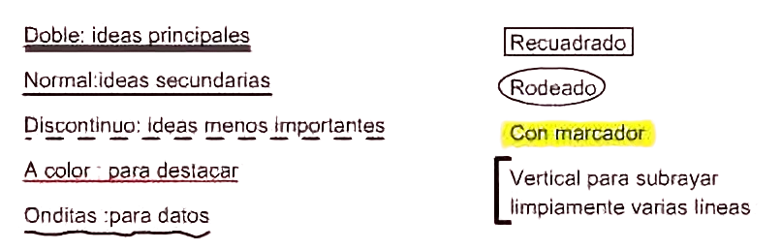

# Example of highlighting, underlining and annotating

In this video, you have an example of how to apply highlighting, underlining and annotations in a commented way: <https://youtu.be/A4LiQwIoeSQ>

Next figure is an example of underlined and annotated text.

